**00CLASS ASSESSMENT – III**

|  |  |  |  |  |
| --- | --- | --- | --- | --- |
| **S. No.** | **Profiles For Platform Creation** | **Link to the Student Profile** | **Screenshots** | **Any Accomplishments** |
| 1 | GitHub | <https://github.com/Kaifislam48> |  | * 3 repositories |
| 2 | Figma | <https://www.figma.com/@kaifislam48> |  | Logo |
| 3 | Quora | <https://www.quora.com/profile/Kaif-Islam-1> |  | * 2 answers with upvotes * Member since April 2018 |
| 4 | Stack Overflow | <https://stackoverflow.com/users/20499033/kaif-islam> |  | * 1 Bronze Badges |
| 5 | Hacker Rank | <https://www.hackerrank.com/kaifislam48> |  | * 10 stars badge * 546 Hackos |
| 6 | Hacker Earth | [ackerearth.com/@kaif42](mailto:ackerearth.com/@kaif42) |  | * 3 Stars Badge * 340 Hackerearth Points |
| 7 | GeeksforGeeks | <https://auth.geeksforgeeks.org/user/kaifislam4> |  | * Rank: 7321 |
| 8 | Git | <https://github.com/Kaifislam48/GitBash/> | Creating Git account using Git BASH command line | GitHub repository by using Git |

**Important Points to be considered for CA-3 (CSE-111)**

1. Students need to create their accounts on the aforementioned platforms either with their full names or university-allocated registration numbers only.
2. For GitHub, the repository should consist of all of the students’ project files and each file's revision history. Make sure that you also check the discussion and management of the student’s project's work within the repositor

9. CV

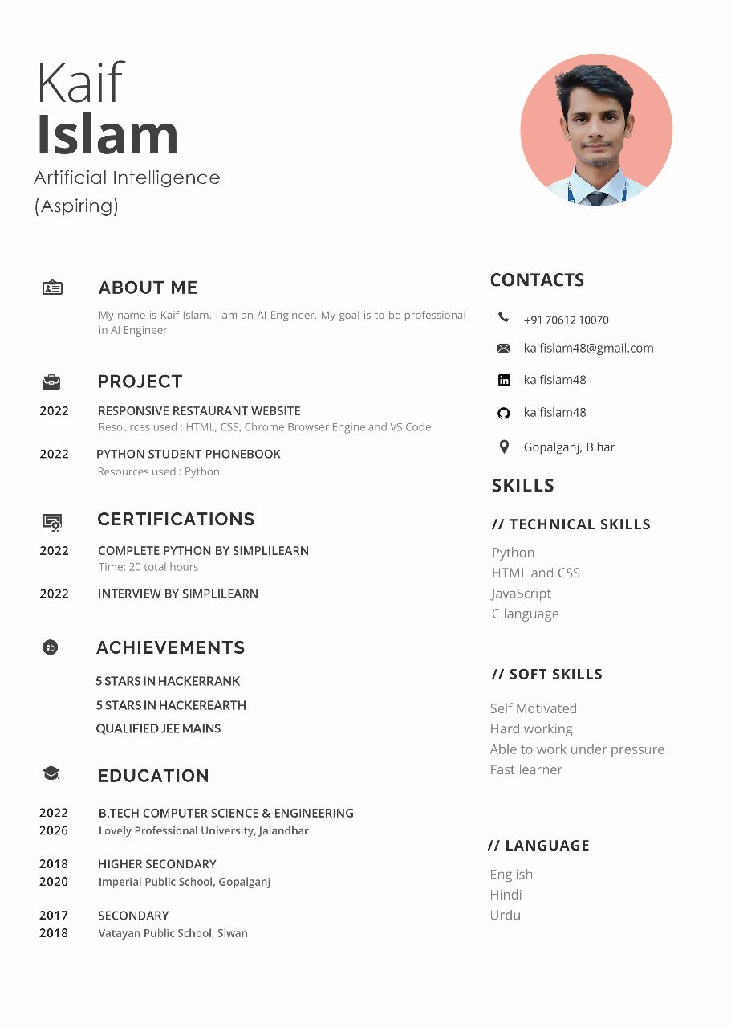

10. MOOCs and Certifications

1. Python for Beginners  
     
   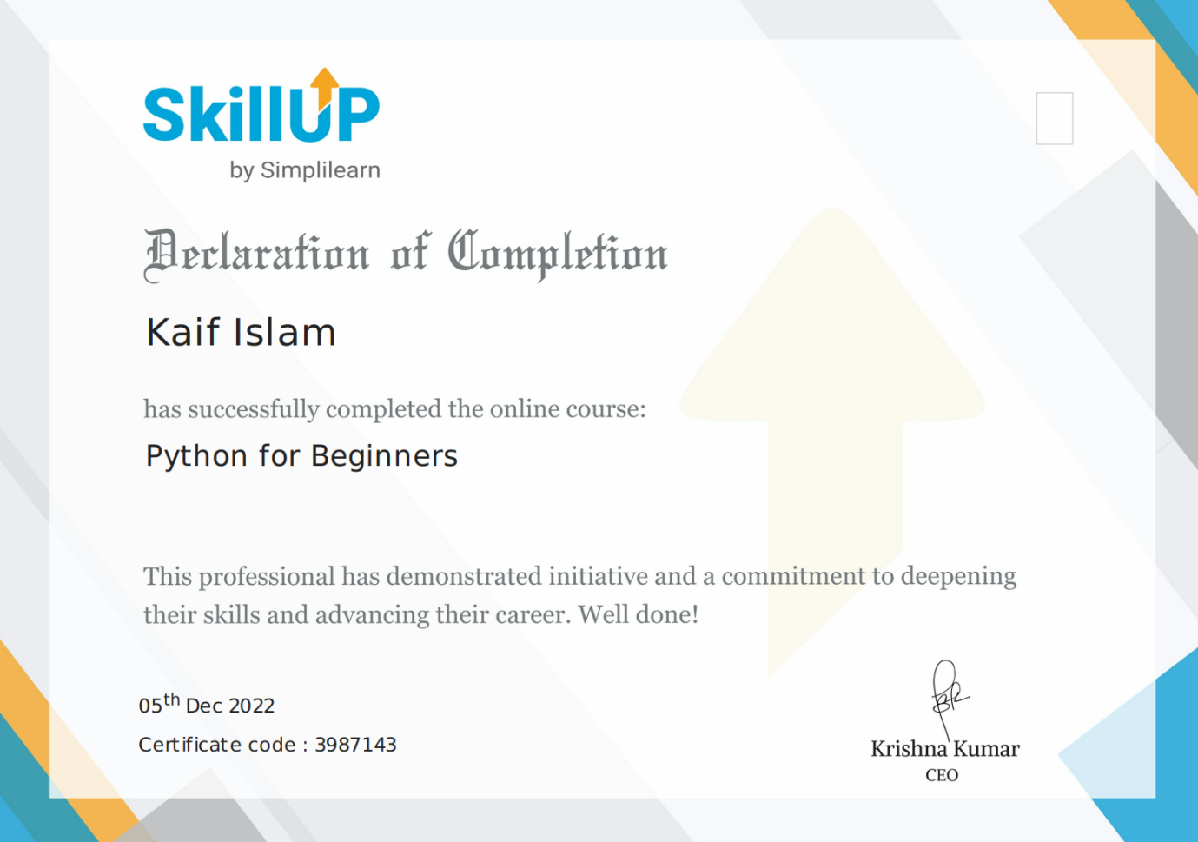
2. Getting started with Interview Preparation  
     
   